**PROJECT DEVELOPMENT PHASE**

**TESTING**

|  |  |
| --- | --- |
| **TEAM ID** | **PNT2022TMID39315** |
| **PROJECT NAME** | **NUTRITION ASSISTANY APPLICATION** |
| **MAXIMUM MARKS** | **10 MARKS** |

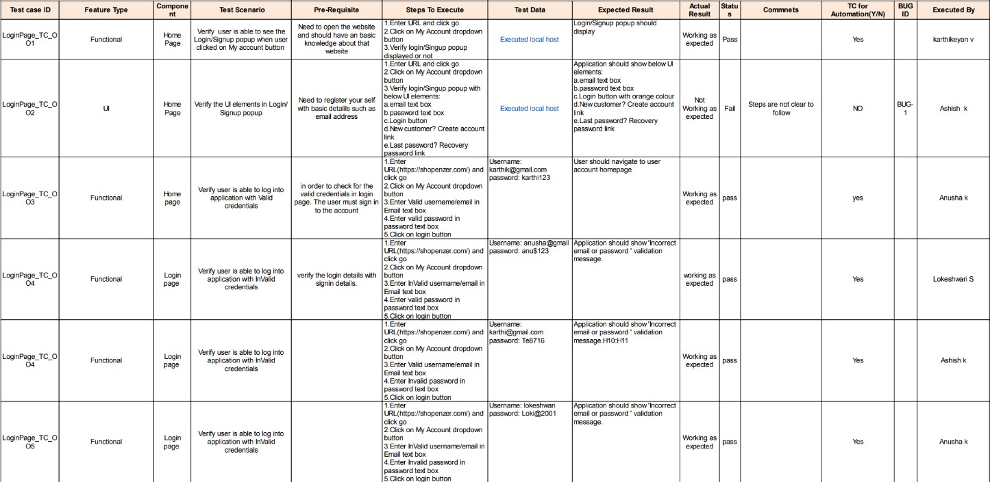**TEST CASES**